February 19, 2022

*Via E-mail:* <<OPPOSING_COUNSEL_NAME>>

<<OPPOSING_COUNSEL_EMAIL>>

c/o Claims Department

***RE: Request for Deposition Dates***

*<<PROVIDER_SUITNAME>> a/a/o <<INJUREDPARTY_NAME>> v. <<INSURANCECOMPANY_SUITNAME>>, Case No.* <<INDEXORAAA_NUMBER>>

Dear Counselor,

I previously sent you a request for dates of availability for deposition of Defendant’s Independent Adjuster and/or Field Adjuster, regarding the claim at issue in the above-referenced matter.

This is a friendly reminder that the Defendant provide dates of availability for up to three (3) months from the date of this letter to my scheduling assistant at depositions@flinslaw.com.

If you fail to provide dates certain within ten (10) days of this letter, we will assume that all dates are available. Should you wish to discuss this matter further, please feel free to contact my office.

Thank you for your anticipated cooperation in this matter.

Sincerely,

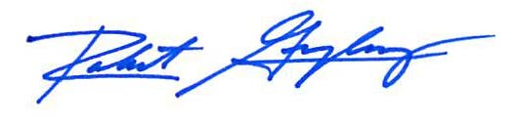

Robert F. Gonzalez, Esq.